Activity | Data Type
Number of beatings from Wife | Discrete
Results of rolling a dice | Discrete
Weight of a person | Continuous
Weight of Gold | Continuous
Distance between two places | Continuous
Length of a leaf | Continuous
Dog's weight | Continuous
Blue Color | Discrete
Number of kids | Discrete
Number of tickets in Indian railways | Discrete
Number of times married | Discrete
Gender (Male or Female) | Discrete
Q1) Identify the Data type for the Following:

Q2) Identify the Data types, which were among the following
Nominal, Ordinal, Interval, Ratio.
Data | Data Type
Gender | Nominal
High School Class Ranking | Ordinal
Celsius Temperature | Interval
Weight | Ratio
Hair Color | Nominal
Socioeconomic Status | Ordinal
Fahrenheit Temperature | Interval
Height | Ratio
Type of living accommodation | Ordinal
Level of Agreement | Ordinal
IQ(Intelligence Scale) | Interval
Sales Figures | Interval
Blood Group | Nominal
Time Of Day | Interval
Time on a Clock with Hands | Nominal
Number of Children | Nominal
Religious Preference | Nominal
Barometer Pressure | Interval
SAT Scores | Interval
Years of Education | Ordinal

Q3) Three Coins are tossed, find the probability that two heads and one tail are obtained?
Sol) Sample space of the Event, S = { TTT, HHH, HHT, TTH,
HTH, THT, HTT, THH }
No: of observations with two heads and one tail = 3
Total no: of observations = 8
Probability(Two heads and one tail) = Favourable Outcomes / Total Outcomes
= 3/8
= 0.375
Therefore, the probability of obtaining two heads and one tail when 3 coins are tossed is 0.375.

Q4) Two Dice are rolled, find the probability that sum is
- Equal to 1
- Less than or equal to 4
- Sum is divisible by 2 and 3
Sol) Sample space, S = { (1,1) (1,2) (1,3) (1,4) (1,5) (1,6)
(2,1) (2,2) (2,3) (2,4) (2,5) (2,6)
(3,1) (3,2) (3,3) (3,4) (3,5) (3,6)
(4,1) (4,2) (4,3) (4,4) (4,5) (4,6)
(5,1) (5,2) (5,3) (5,4) (5,5) (5,6)
(6,1) (6,2) (6,3) (6,4) (6,5) (6,6) }

a) Equal to 1:
Observations with sum is equal to 1 = 0
Total Observations = 36
Probability ( Sum is equal to 1) = 0/36 = 0

b) Less than or equal to 4:

Observations with sum less than or equal to 4 = 6
Total No: of Observations = 36
Probability ( Sum less than or equal to 4 ) = 6/36
= 0.166

Therefore, probability of sum less than or equal to 4 is 0.166

C) Sum is divisible by 2 and 3

Observations with Sum is divisible by 2 and 3 = 24
Total No: of Observations = 36
Probability ( Sum is divisible by 2 and 3 ) = 24/36
= 0.66

Q5) A bag contains 2 red, 3 green and 2 blue balls. Two balls are drawn at random. What is the probability that none of the balls drawn is blue?
Sol) Probability of drawing two balls with none of the blue balls =
= Total probability - Probability of drawing two balls that are blue balls
= 1 - [ (2/7) + (1/6) ]
= 1 - [ 0.285 + 0.166 ]
= 1 – 0.451
= 0.549

Q6) Calculate the Expected number of candies for a randomly selected child
Below are the probabilities of count of candies for children (ignoring the nature of the child-Generalized view)
CHILD | Candies count | Probability
A | 1 | 0.015
B | 4 | 0.20
C | 3 | 0.65
D | 5 | 0.005
E | 6 | 0.01
F | 2 | 0.120
Child A – probability of having 1 candy = 0.015.
Child B – probability of having 4 candies = 0.20
Sol) The expected number of candies is E(x) = Σ(x*p(x))
E(x) = [(1*0.015)+(4*0.20)+(3*0.65)+(5*0.005)+(6*0.01)+(2*0.120)]
E(x) = 237/100
E(x) = 2.37

Q7) Calculate Mean, Median, Mode, Variance, Standard Deviation, Range & comment about the values / draw inferences, for the given dataset
-For Points, Score, Weigh
-Find Mean, Median, Mode, Variance, Standard Deviation, and Range and also Comment about the values/ Draw some inferences.
Sol) Writing the code in Spyder by using Q7.csv file
a)Points:
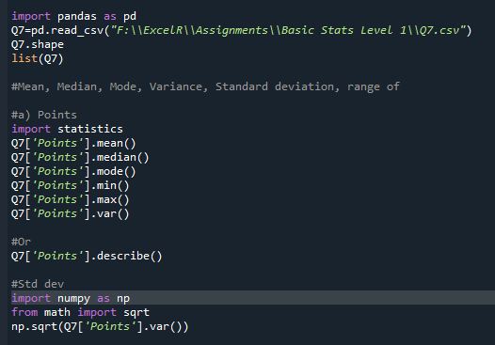
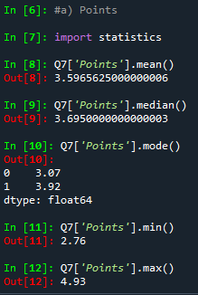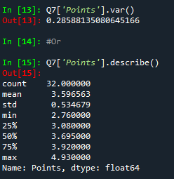
b) Score:
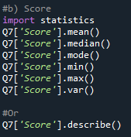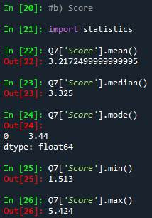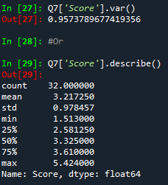
c)Weigh:
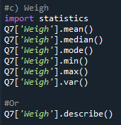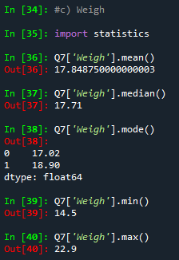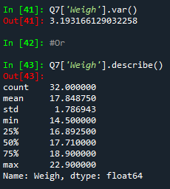

Q8) Calculate Expected Value for the problem below
The weights (X) of patients at a clinic (in pounds), are 108, 110, 123, 134, 135, 145, 167, 187, and 199
Assume one of the patients is chosen at random. What is the Expected Value of the Weight of that patient?
Sol) The expected value of the weight of the patient is nothing but mean(X).
Mean(X) = = 145.33 pounds

Q9) Calculate Skewness, Kurtosis & draw inferences on the following data
Cars speed and distance (Use Q9_a.csv)
Sol) By writing the code in python and checking the skewness and kurtosis
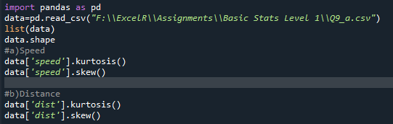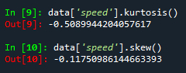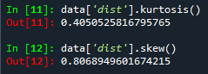
Inference: From the result we can see that variable ‘Speed’ it is negatively skewed data i.e.,(Mean<Median<Mode) and also have Negative kurtosis i.e.,(Platy Kurtosis)
From the result we can see that variable ‘Dist’ it is positively skewed data i.e.,(Mean>Median>Mode) and also have Positive kurtosis i.e.,(Lefto Kurtosis)
SP and Weight(WT),Using Q9_b.csv and checking its skewness and kurtosis
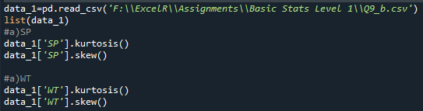
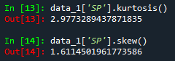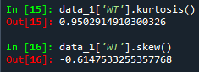
Inference: From the result we can see that variable ‘SP’ it is positively skewed data i.e.,( Mean>Median>Mode) and also have Positive kurtosis i.e.,(Lefto Kurtosis)
From the result we can see that variable ‘WT’ it is negatively skewed data i.e.,(Mean<Median<Mode) and also have Positive kurtosis i.e.,(Lefto Kurtosis)

Q10) Draw inferences about the following boxplot & histogram

Inference for the histogram, the data speaks about the chick weights which looks to be positively skewed in which Mean>Median>Mode. Most of the chick weights fall under the category of 50-100.
Inference for the boxplot, there are outliers present in the graph. The lower line of the box plot represents Q1(Quartile 1-25 percentile), the middle line represents Median(50 percentile) and the last above line represents Q3(Quartile 3-75 percentile).

Q11) Suppose we want to estimate the average weight of an adult male in Mexico. We draw a random sample of 2,000 men from a population of 3,000,000 men and weigh them. We find that the average person in our sample weighs 200 pounds, and the standard deviation of the sample is 30 pounds. Calculate 94%, 98%, 96% confidence interval?
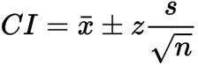
Here the parameters are as follows:
Population = N = 3,000,000
Sample size = n = 2000
Confidence level value = Z
Mean = x =200
Standard deviation = s = 30
We can calculate confidence intervals with the formula = x̅ ± Z(σ / √n)
- For 94% confidence interval: 200 ± 1.881(30/√2000) = 200 ± 1.2681
- For 98% confidence interval: 200 ± 2.326(30/√2000) = 200 ± 1.5603
- For 96% confidence interval: 200 ± 2.05(30/√2000) = 200 ± 1.3751

Q12) Below are the scores obtained by a student in tests
34,36,36,38,38,39,39,40,40,41,41,41,41,42,42,45,49,56
- Find mean, median, variance, standard deviation.
- What can we say about the student marks?
Sol) Mean(X)=
Mean(X)= 41 marks

Median ➔ Arrange in ascending order
34,36,36,38,38,39,39,40,40,41,41,41,41,42,42,45,49,56
As no. of observations are even, median is avg. of middle most two values
Median = = 40.5 marks

Mode ➔ Most repeated observation is 41 marks, so mode = 41 marks
Inference: we can observe that the Mean = Mode >Median
The marks obtained by students can be positively skewed in nature

Q13) What is the nature of skewness when mean, median of data are equal?
Sol: When Mean=Median=Mode, It is symmetrical in nature.

Q14) What is the nature of skewness when mean > median?
Sol: When Mean>Median, It is positively skewed in nature.

Q15) What is the nature of skewness when median > mean?
Sol: When Median > Mean, It is negatively skewed in nature.

Q16) What does positive kurtosis value indicates for a data?
Sol: Positive kurtosis means peak of the normal distribution above it. The spread of the normal distribution is very less in positive kurtosis.

Q17) What does negative kurtosis value indicates for a data?
Sol: Negative kurtosis means peak of the normal distribution below it. The spread of the normal distribution is more in negative kurtosis.

Q18) Answer the below questions using the below boxplot visualization.

What can we say about the distribution of the data?
Sol: The box plot looks to be concentrated more on right of the scale.
There are no outliers present in the plot.

What is nature of skewness of the data?
Sol: As per the box plot, the Mean<Median, it looks to be negatively skewed.

What will be the IQR of the data (approximately)?
Sol: Quartile1=Q1=25 percentile=10
Quartile2=Q2=50 percentile (Median)=15
Quartile3=Q3=75 percentile=18
Inter Quartile Range(IQR) = Q3 – Q1 = 18 – 10 = 8

Q19) Comment on the below Boxplot visualizations?

Draw an Inference from the distribution of data for Boxplot 1 with respect Boxplot 2.
Sol) (1) box-plot is more concentrated and while (2) box-plot has a more distributed data. When we talk about range of both box-plots (1) has the range of 237.5 - 287.5 = 50 and (2) has the range of 200 - 350 = 150 and hence (2) has more range. The kurtosis value of (1) will be greater than (2) since (1) is more concentrated.
Another inference is that the median values of both the box-plots are equal.
Q 20) Calculate probability from the given dataset for the below cases
(Data _set: Cars.csv)
Calculate the probability of MPG of Cars for the below cases.
MPG <- Cars$MPG
  - P(MPG>38)
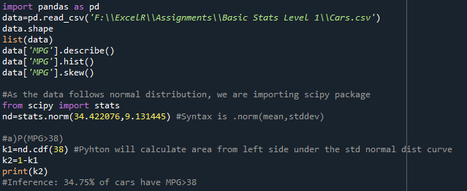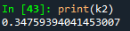

Inference: 34.75% of cars have MPG>38

  - P(MPG<40)
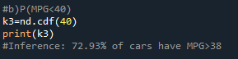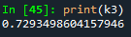

Inference: 34.75% of cars have MPG<40

  - P (20<MPG<50)
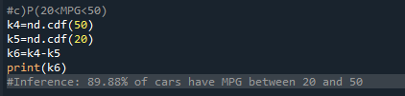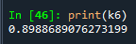
Inference: 34.75% of cars have MPG between 20 and 50.

Q 21) Check whether the data follows normal distribution
- Check whether the MPG of Cars follows Normal Distribution
Dataset: Cars.csv
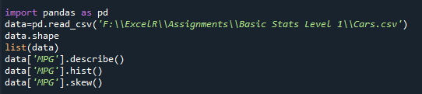
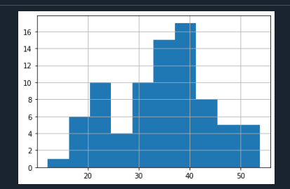

Inference: The data looks to be normally distributed and skewness is also under the acceptable range of -0.5 to +0.5
- Check Whether the Adipose Tissue (AT) and Waist Circumference(Waist) from wc-at data set follows Normal Distribution
Dataset: wc-at.csv
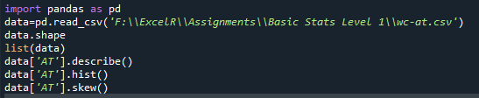
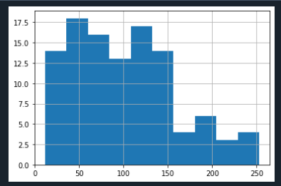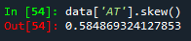

Inference: The data looks to be positively skewed and skewness is slightly deviating from the acceptable range of -0.5 to +0.5

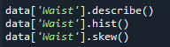
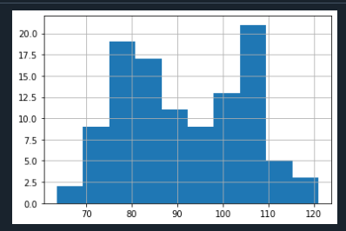
Inference: The data looks to be normally distributed and skewness is also under the acceptable range of -0.5 to +0.5

Q 22) Calculate the Z scores of 90% confidence interval,94% confidence interval, 60% confidence interval
from scipy import stats
from scipy.stats import norm

#z-score of 90% confidence interval
stats.norm.ppf(0.95)

#z-score of 94% confidence interval
stats.norm.ppf(.97)

#z-score of 60% confidence interval
stats.norm.ppf(-60)
Confidence Interval | Z-Scores
90% | 1.645
94% | 1.881
60% | 0.25

Q 23) Calculate the t scores of 95% confidence interval, 96% confidence interval, 99% confidence interval for sample size of 25.
Confidence Interval | t-Scores
95% | 2.262
96% | 2.054
99% | 2.33

Q 24) A Government company claims that an average light bulb lasts 270 days. A researcher randomly selects 18 bulbs for testing. The sampled bulbs last an average of 260 days, with a standard deviation of 90 days. If the CEO's claim were true, what is the probability that 18 randomly selected bulbs would have an average life of no more than 260 days
Sol) t - statistics for the data is given as follows:
x = mean of the sample of bulbs = 260
μ = population mean = 270
s = standard deviation of the sample = 90
n = number of items in the sample = 18
t = - 0.471
The likelihood that t - 0.471 with 17 degrees of freedom is smaller than the t-value obtained if the population mean is true. With 17 degrees of freedom and a t score of -0.471, the likelihood of the bulbs surviving less than 260 days on average is 0.3218, assuming a 300-day mean life.

